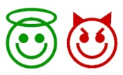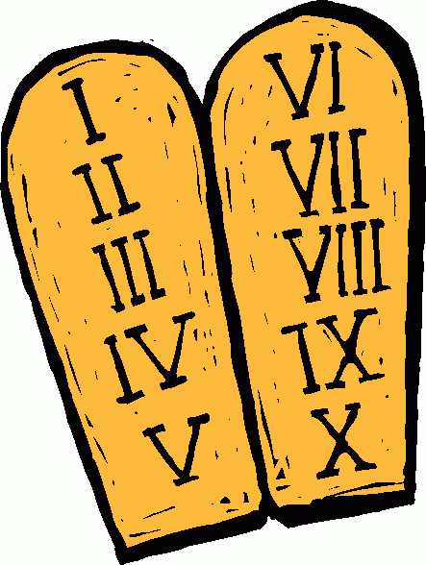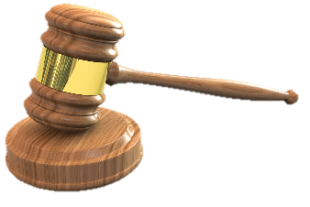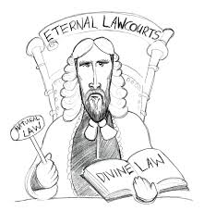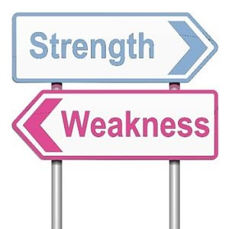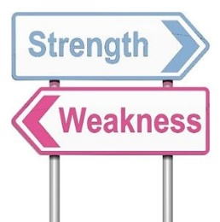Mucha Wo Minagara Milk tea Regular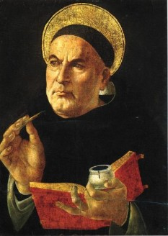Mucha Wo Minagara Milk tea RegularMucha Wo Minagara Milk tea RegularMucha Wo Minagara Milk tea RegularMucha Wo Minagara Milk tea RegularMucha Wo Minagara Milk tea RegularMucha Wo Minagara Milk tea RegularMucha Wo Minagara Milk tea Regular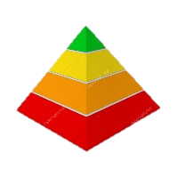Mucha Wo Minagara Milk tea RegularMucha Wo Minagara Milk tea RegularMucha Wo Minagara Milk tea RegularMucha Wo Minagara Milk tea Regular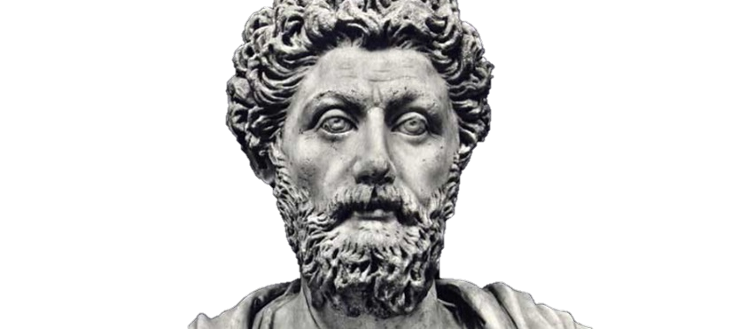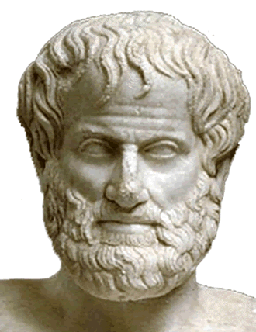Mucha Wo Minagara Milk tea Regular

Natural Law is the moral thinking that we are all able to do. All humans have the capacity to consider and work out the moral rules necessary for achieving our purpose. This involves a rational reflection on our human nature and considering how we   
might ‘do good and avoid evil’.

* It is **clear**, with firm moral principles
* Most people agree that the primary precepts are **desired** in human life
* The secondary precepts are **flexible** and dependant on circumstance or situation. The doctrine of double effect allows this flexibility
* Natural Law **values life** and values rights
* **Grotius** said that belief in Natural Law does not require belief in God
* Natural Law may be wrong to assume that there is a **universal telos** for human beings, e.g. some people do not want children
* If natural means in accordance with   
  our nature, then a gay person might   
  be right to claim that **homosexuality** is natural to them (hence no reproduction)
* Natural Law commits the **naturalistic fallacy**. It is guilty of observing what commonly happens in nature and then arguing that this is what must happen. This would be like observing the shape of human teeth, that they are well designed for eating meat, and then claiming that it was morally wrong to just eat vegetables.
* Perhaps the biggest issue with the idea of telos is that there may not be a telos or purpose at all. Sartre argues that there is no ultimate purpose to human life.
* Hence, linked to the above point, it would seem that the idea of telos is linked to the idea of a creator God. If there is **no God**, there can be **no telos**.



**Synderesis** – the inner principle directing a person towards good and away from evil

Abortion: Catholics would never abort due to the first precept.

Euthanasia: The intention of delivering pain relief is not to kill the patient

Antigone: There are natural laws, like burial of the dead, we all follow

Sexual ethics: Affairs are an apparent good, not a real good.

The ethical theory of Natural Law suggests that there is an order to the universe and that all things are better when they act according to this order or purpose.

**Secondary precepts** are more specific rules that can be deduced from the primary precepts. For example, given that preservation of life is a primary precept, we can figure out that killing a fellow human being is wrong. Whereas the primary precepts are fixed, there is some flexibility in the secondary precepts as these are based on how the primary precepts apply in specific circumstances.

While **Catholic interpretations** of Aquinas have made quite fixed secondary precept – for example, a rejection of contraception given that the primary precept is reproduction – Aquinas himself never goes this far. For Aquinas, the secondary precepts are possible applications rather than hard and fast rules.

The main moral rule or precept according to Aquinas is that we should ‘do good and avoid evil’ (synderesis). All other moral rules are   
taken from this.

**The primary precepts**

Aquinas believed that, when we reflect   
on our telos and understand the synderesis rule, there are five primary precepts or rules that emerge:

1. **Preservation of life**
2. **To reproduce**
3. **To learn**
4. **To live in an ordered society**
5. **To worship God**
6. Laws that were implemented   
   to prevent peaceful protest by civil rights groups in 1960s America could be broken, argued **Martin Luther King**,   
   as they were ‘unjust’ laws.
7. **Nazi leaders** on trial for war crimes argued that they were   
   just following orders; they   
   were only obeying the law.   
   This was rejected by judges   
   on the grounds that surely ‘nature’ shows that such laws were morally wrong.

For Aquinas, there are **four tiers** (levels) of law, each dependent on the one above it. In order of importance, they are: Eternal Law, Divine Law, Natural Law and Human Law.

Humans Laws are the customs and practices of a society. They are devised by governments and by societies. Ideally, it should be based on what we reason from Natural Law.

The Divine Law refers to the law revealed by God through the commands and teachings through revelation, for example in scripture. These include the Ten Commandments and the moral teachings of Jesus in the Sermon on the Mount.

The Eternal Law is the law known in the mind of God. In simple terms, it is his knowledge of what is right and wrong, which we may be unable to understand.

Aquinas draws several key lessons from these ancient thinkers in producing his own theory of Natural Law.

* **Telos** –humans have a purpose or end
* **Reason** – the world is ordered and rational,
* **Nature** – we have a human nature and it is important to do what is ‘natural’

These lessons, in addition to Christian ideas   
taken from the   
Bible, are key   
to understand  
-ing Aquinas.

Another source of Natural Law thinking came from the **Stoics**. Stoicism viewed the world as an ordered place, arranged by nature or by the gods in the best way possible, according to nature’s rules. Stoicism favoured the   
 **rational** over the emotional.

**Aristotle** believed that the universe   
and everything within it had a **telos** (a purpose or aim). He arrives at this from his theory of the four causes. The telos is the final cause. Aristotle sees the telos of human beings as **Eudaimonia**. Its main meaning is happiness but not in the sense of pleasure but rather in fulfilment and human flourishing.  
 Eudaimonia requires a full   
human life.