The Structure and Functions of the Skeletal System – The Key Body Systems and their Impact on Performance
The functions of the skeleton:  - Protection of vital organs  Cranium protects the brain when heading a ball  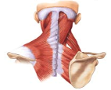  - Muscle attachment  Bones provide anchors for muscles to attach.  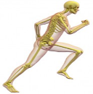  - Joints for movement  Bones act as levers to create movement.  - Platelets  Platelets clot blood when we are cut to stop the bleeding.  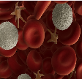  - Blood cell production  Red blood cells carry oxygen  White blood cells fight infection.  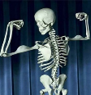  - Store calcium & phosphorus  Calcium and Phosphorus is stored in the bones to keep them strong. | Classification of bones:  Long bones act as levers so we can move. Examples are the humerus, ulna and femur.  Short bones are important for weight bearing and to absorb shock Examples are the carpals and tarsals.  Flat bones usually protect organs. Examples are the ribs, pelvis and scapula.  Irregular bones have odd shapes and perform a range of functions. Examples are the bones of the vertebrae.  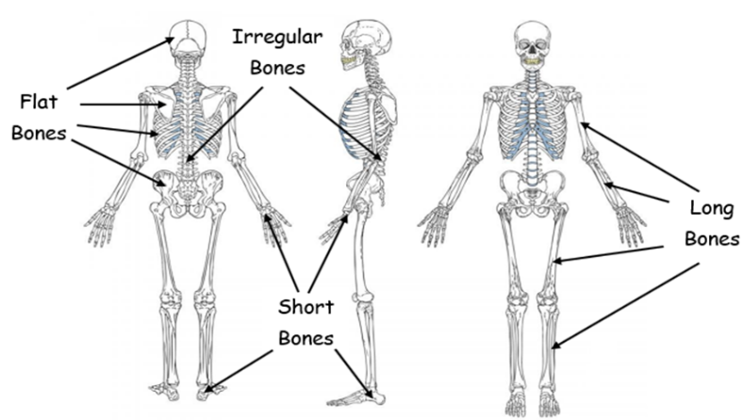 | Structure of the skeleton:
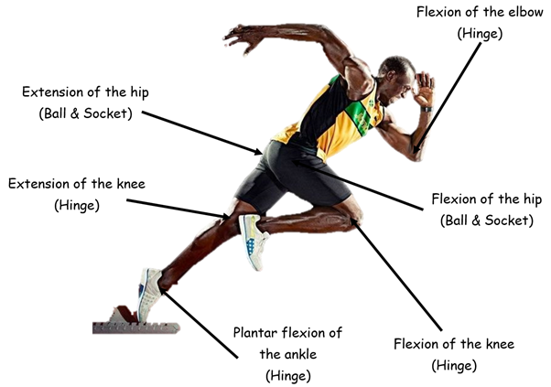  Movement possibilities at joints:  Flexion: bending movement (decreases angle)  Extension: Straightening movement (increase angle)  Abduction: Moving away from midline  Adduction: Moving towards the midline  Plantar flexion: Pointing the toes downwards  Dorsi flexion: Pointing the toes upwards  Rotation: Rotation around a joint or axis  Circumduction: flexion/extension Abduction/adduction |  | The role of ligaments and tendons:  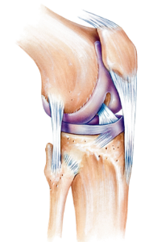  A ligaments main function is to join bone to bone. Ligaments help stabilise joints and prevent dislocation.  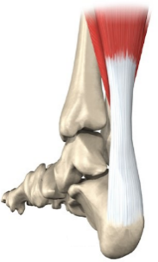  Tendons attach muscle to bone. Tendons help provide powerful movements such as kicking, jumping and kicking. | Vertebral column:  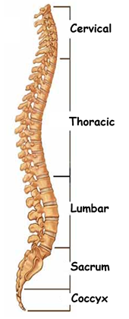
Classification of joints:
Hinge
E.g. Elbow & Knee
Ball & Socket
E.g. Hip & Shoulder
Condyloid
E.g. Wrist
Pivot
E.g. Neck (axis & Atlas)
